(Approx. 305 words)

Webmaster Wanderings
Aukey USB Outlet with Night Light Plug-in
Curt Potsic, Webmaster, Space Coast PCUG, FL
June 2019 issue, The Space Coast Journal
www.scpcug.com
cmpotsic (at) att.net.

I spotted this Aukey USB outlet with Night Light Plug-in on Amazon one day. It was on sale for $6 off the $19.99 price and I thought it was a good deal for $13.99. https://www.amazon.com/gp/product/B074MVWM6V

It’s a wall outlet that has 4 AC receptacles and 2 USB charging ports on the sides along with a night light on the front. Plus it also has surge protection. It can be used in a bedroom, bathroom, kitchen, etc.
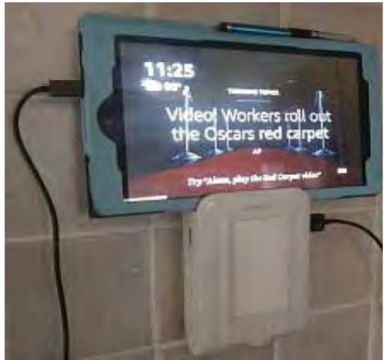
We have it in the kitchen where it’s ideal for charging cell phones and tablets. The photo on Amazon’s site shows it charging a cell phone resting on the top ledge but I found it also works fine with 7” or 8” tablets resting on its top ledge. Also the night light brightness varies with how dark it is and can be turned off with the circular button below the light panel.

What intrigued me was this looked like a great way to charge my wife’s Fire HD 8 Tablet. She has a compatible 7th generation tablet which has “Show Mode.” The HD 8 Tablet in Show Mode has basically the same functionality as an Echo Show which has a 10” screen but sells for $229.99. With the Aukey Outlet serving as a stand, the tablet in Show Mode was perfect just resting against the wall above the kitchen counter. This sure beat buying Amazon’s Show Mode Charging Dock for $39.99 (https://www.amazon.com/All-New-Charging-Compatible-Generation-Tablets/dp/B07BNXZDJ3).

Plus with Amazon’s Charging Dock you have to remove the tablet’s protective cover for the dock’s charging socket to fit into place. With the Aukey unit the tablet’s protective cover stays on and a standard USB charging cable is used.
